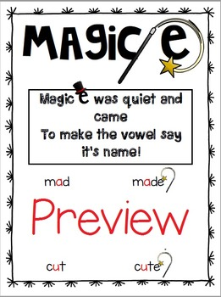

Magic-e

Here is Magic-e

He is quiet as can be.

He jumps onto the end of words,
has enough magical power to stretch over ONE consonant letter, touch the short vowel and
change it
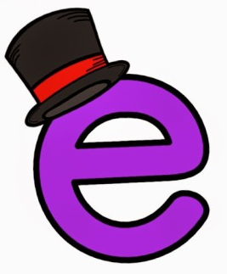
from short to long.



