,
The Short Vowel Book

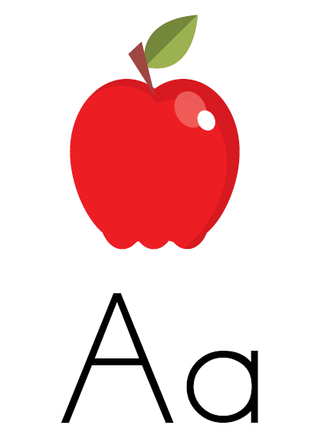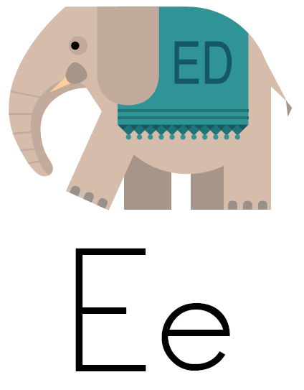

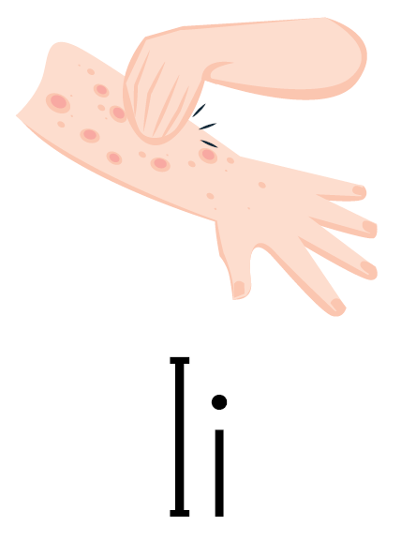

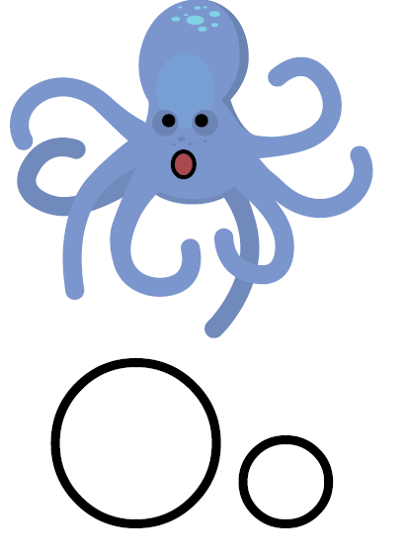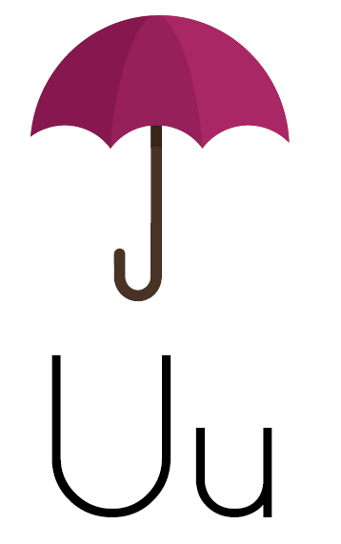

Created by Samantha Brooks

Apples, apples, take a bite.
ă ă ă

They’re good for you both day and night.
ă ă ă

It’s really amazing how it could be, that
something so sweet is good for me.
ă ă ă

ă

1
2

Ed the Elephant can barely hear
ĕ ĕ ĕ

He puts his hand up by his ear
ĕ ĕ ĕ

Even though this is weird, it makes it so Ed can hear.
ĕ ĕ ĕ

ĕ

4
3

Something red and itchy, is all over me
ĭ ĭ ĭ

I try not to scratch, but need some relief
ĭ ĭ ĭ

Mom put medicine on and told me to stop.
Will it soon heal?
I think it will not.
ĭ ĭ ĭ

ĭ

6
5

Ollie Octopus loves to sing
ŏ ŏ ŏ

He opens his mouth for everything
ŏ ŏ ŏ

He wiggles and squiggles his arms, that’s true.
Singing and dancing is all he’ll do.
ŏ ŏ ŏ

ŏ

8
9

I’m trying hard to decide.
ŭ ŭ ŭ

Do I really need my umbrella outside?
ŭ ŭ ŭ

As I open and close it, it’s hard to guess…..
Do I need it or not?
What is best?
ŭ ŭ ŭ

ŭ

10
7

